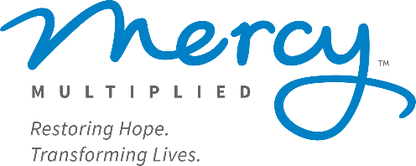

Below is contact information for ministries that may meet the needs you mentioned or may be able to provide additional referrals for you. Although Mercy Multiplied seeks to provide relevant referrals, please understand that these are not recommendations and we make no claims on the effectiveness of any of these programs in individual situations. We pray God’s blessings on you as you seek His help in the best place for your needs.

Referral List:

Counseling Services
- Banner Mental Health Institute 318-396-8152

- Granberry Counseling Center 318-345- 8200

- Crossings Counseling 318-504-9200
Tami Bullock

- Heather Mullins Counseling 318-303-3278
heather.mullins@heathermullinscounseling.com

- Freddie Amos
Freddie@havenhousecounselingllc.com

- Strategic Counseling Solutions-Traci Simmons 318-450-8719

- Oasis Family Therapy- 318-321-3261
Kelsie Lenard
Jenna Gonzalez

- Better Path Counseling and Wellness 318-577-2729
(Beth V. & Sanya R.)

- Living Water Family Services 318-343-6966

- First West Counseling 318-322-1422

- Snow Counseling 318-917-4101
Gil Martin

- Granberry/North Monroe location 318-345-8200
Skylar Artigue

- Dianne Davis- Psychiatric Nurse Practitioner 318-816-5116

- Gloria D. Mays- Psychiatric Nurse Practitioner 318-251-1233

- Dragon Fly Harbor- (Jennifer or Tiffany)
thedragonflyharbor@gmail.com

- Healing Journey- Myisha Jackson 318- 582-5147

- Shreveport Family Counseling 318-518-3326

- The Hope Center 318-398-1788

Community Resources
- Rachel Hanes-Nutritionist
freedomfoundnutrition@gmail.com

- P31 Recovery House 318-237-8857

- Louisiana Baptist Children’s Home 318-343-1244
(For mothers and children)

- Louisiana Teen Challenge 318-648-1100
(Minden, for mothers and children)

- Bawcomville Hope (Rachel) 318-235-3879

- Freedom 13 (Sex Trafficking Resource)- Ruston 318-255-1244

- Two Penny Missions 318-355-2423

- Salvation Army 318-325-1755

- Family Promise 318-645-4101
(Services for Unhoused)

- The Center for Children and Families 318-398-0945

- The Renewal Center of NE Louisiana 318-605-2974
(Services for Unhoused)

- The Wellspring for Women and Children 318-323-1505

- Fresh Start Addiction Recovery Services 318-435-7061
(Winnsboro)

- Rays of Sonshine Women’s Addictions 318-323-0502
Recovery Services

- Freedom Challenge (Bastrop) 318-669-1982

- Pecan Haven Addiction Recovery Services 318-600-3333

